## Project Tender

# Project: www.OnlyRugby.com

Only Rugby

Team: Men at Work

Ivan Henning (13008219)

Muller Potgieter ()

Johan van Rooyen (11205131)

Herman Keuris ()

?? ()

Department of Computer Science, University of Pretoria

Date: 2015-05-04

Photo

# The Team

## Ivan Henning

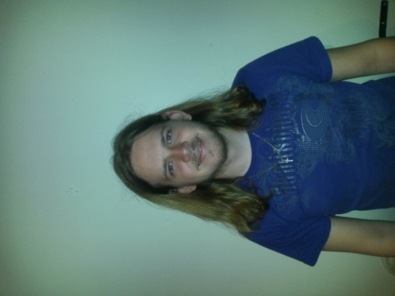

### Interests

* IT programming
* Latest technology
* Gaming
* Sport (cricket, rugby and hockey)

### Technical Skills

Experienced in coding in the following languages/mark-ups/standards:

C, C++, C#, Java, Pascal, HTML, CSS, XML, XSLT, JavaScript, JNode, PHP, AJAX, JQuery and MySQL.

Experience in working in the following fields:

* Operating Systems
* Networks
* Website Development
* Web Systems (server- and client side processing)
* Database management

### Past Experiences

* I have work on a lot of website development and experience with using PHP and MySQL.
* I have worked on a project before that involved creating a web site that allows users to sell and buy products. Many of the features of that website are the same as the current project.
* Also somewhat of a rugby fan and knowledge about the game.

### Non-technical Strengths

* Work well in a team to accomplish goals.
* Quick learner.
* Organised.
* Work well under pressure.
* I'm realistic and debate matters logically.
* Task orientated and objective.
* Thinks outside of the box.

### What makes you want to do the project?

It is always exciting to develop a website as it is interesting and fun.

## Joseph Muller Potgieter

### Interests

### Technical Skills

### Past Experiences

### Non-technical Strengths

### What makes you want to do the project?

## Johan van Rooyen

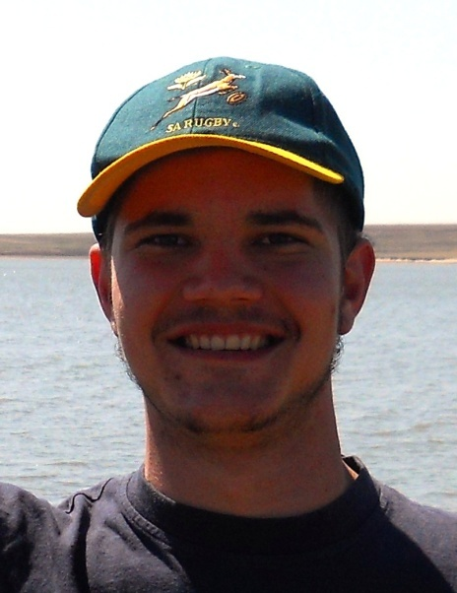

### Interests

* Fishing
* Hunting
* Adrenaline sports
* Computer Games
* Website design
* Electronic components and building small appliances

### Technical Skills

* C++ and C
* Java
* HTML, CSS and Javascript Coding
* PHP Development
* SQL Programming (Database Management)
* Novice Android Development
* Technical Support

### Past Experiences

* Worked as a web developer for 12 months in 2011, writing new and editing existing sites, managing resources on a remote server and working in weekly sprints to finish the project.
* Worked with an international team on a web design project, where meetings took place over Skype and collaborating through an private server made transfer of resources possible.

### Non-technical Strengths

* Good Communication skills
* Collaborate well with a team
* Good business knowledge
* Knowledge of Law in South Africa
* Good time management
* Organizational and Management skills
* Great problem solving abilities
* Go-getter

### What makes you want to do the project?

## Herman Keuris

### Interests

### Technical Skills

### Past Experiences

### Non-technical Strengths

### What makes you want to do the project?

## ??

### Interests

### Technical Skills

### Past Experiences

### Non-technical Strengths

### What makes you want to do the project?

# Project Execution